The Jain International School, Kanpur
Class – IV
SUBJECT | SUMMER HOLIDAY HOMEWORK
English | Do the given worksheets.  Roll no. 1 to 3 – Make a chart on Subject and Predicate.  Roll no. 4 to 6 – Make a working model on Kinds of Sentences.  Roll no. 7 to 10 – Make a chart on Punctuation.
Hindi | Do the given worksheets.  Roll No. 1 to 5 : Make a working model on - Hkk"kk foykse “kCn eqgkojs loZuke laKk A  Roll No. 6 to 10 : Make a chart on- foykse “kCn eqgkojs loZuke laKk “kCn A  Roll No. 11 to 16 : Make a working model on- Loj O;atu opu fyax A
Mathematics | Do the given sheets & Learn tables from 5-15.  Projects :- Roll no. 1 & 2 : Make a working model on Addition & Subtraction, Roll no.3 & 4 : Make a chart on Measurements, Roll no. 5 & 6 : Make a working chart on Solid Shapes, Roll no. 7 & 8 : Make a working chart on Multiples and Factors, Roll no. 9 & 10 : Make a working model on Money.
Social Studies | *Do the given worksheets.  Roll no. 1-3- Make a coral island( Take help from page 44)  Roll no. 4-5:- working model of a windmill  Roll no. 6-7:- Chart on industries of India  Roll no. 8-9 Chart on Soils of India  Roll no. 10:- Chart on the Constitution of India.
Science | Do the given worksheets.  Roll no. 1 to 3 Make a working model on Rainwater harvesting  Roll no. 4 to 6 Make a working model on Excretory system  Roll no. 7 and 8 Make a model on Soil profile  Roll no. 9 and 10 Make a model on Three states of matter
Computer | (Roll No. 1 - 5 ) Make a Model on Communication Devices.  (Roll No. 6 - 10 ) Make a Model on different icons of desktop.  Examples- Computer network, Paint, My Computer, any two games icon, MS Word, MS PowerPoint, Whatsapp, Google Chrome, Internet, Explorer, zoom, Gmail, YouTube, folder, MS Excel.
General Knowledge | (Roll No. 1) Make a Model on Be safe ( Reference Page- Book cover)  (Roll No. 2) Make a Model on Yoga for life ( Reference Page- page no. 61)  (Roll No. 3) Make a Model on Disasters ( Reference Page- page no. 49)  (Roll No. 4) Make a Model/ chart on Capitals of Indian states ( Reference Page- page no. 5)  (Roll No. 5,6) Make a Model/ chart on Save Earth, Save Water ( Reference Page no. 21,24,32)  (Roll No. 7,8) Make a Model on 7 wonders Of the World ( Reference Internet)  (Roll No. 9, 10) Make a Model/ chart on Olympic games ( Reference Page- page no. 20,23,35,37)  Write any 20 current affairs in your G.K. notebook.

The Jain International School , Kanpur
Holiday Homework Worksheets - 1
Subject: English
Class – IV
Name:______________________ Date : _____________
_________________________________________________________________________
TOPIC : NOUN
Q. Fill in the blanks with suitable Abstract Nouns from the boxes:-
1. The old man sat near the fireplace and enjoyed its __________________.
2. Albert Einstein said that ________________ is more important than knowledge.
3. Learning what not to do is the most important step on the road to____________.
4. There was __________________ in the dog’s eyes.
5. Have you heard that __________________ is the best policy?
S success, honesty, imagination, warmth, sadness, laughter, friendship, strength, wealth, surprise
6. It took great __________________ and determination to climb that mountain.
7. You must have heard of the saying that health is ______________.
8. His good results did not come as a __________________ to anyone.
I’m full of keys, but I can’t open any door. What am I?
A Piano / Keyboard

The Jain International School , Kanpur
Holiday Homework Worksheets - 2
Subject: English
Class – IV
Name:______________________ Date : _____________
_________________________________________________________________________
Topic – Adjective
Q. In each set of words, circle the words that are Antonyms:-
1. Disobedient - Quiet, Naughty, Noisy
2. Cheap - Miser, Expensive, Poor
3. Boring - Short, Long, Broad
4. Fresh - Dull, Sharp, Pure
5. Energetic - Careful, Cautious, Lazy
6. Outside - Near, Closed, Far
7. Best - Pleasing, Worst, Popular
- Only two English words in current use end in "-gry". They are "angry" and "hungry".
- The opposite of "sparkle" is "darkle."

THE JAIN INTERNATIONAL SCHOOL
HOLIDAY HOME WORK
CLASS-4
Sheet No.1

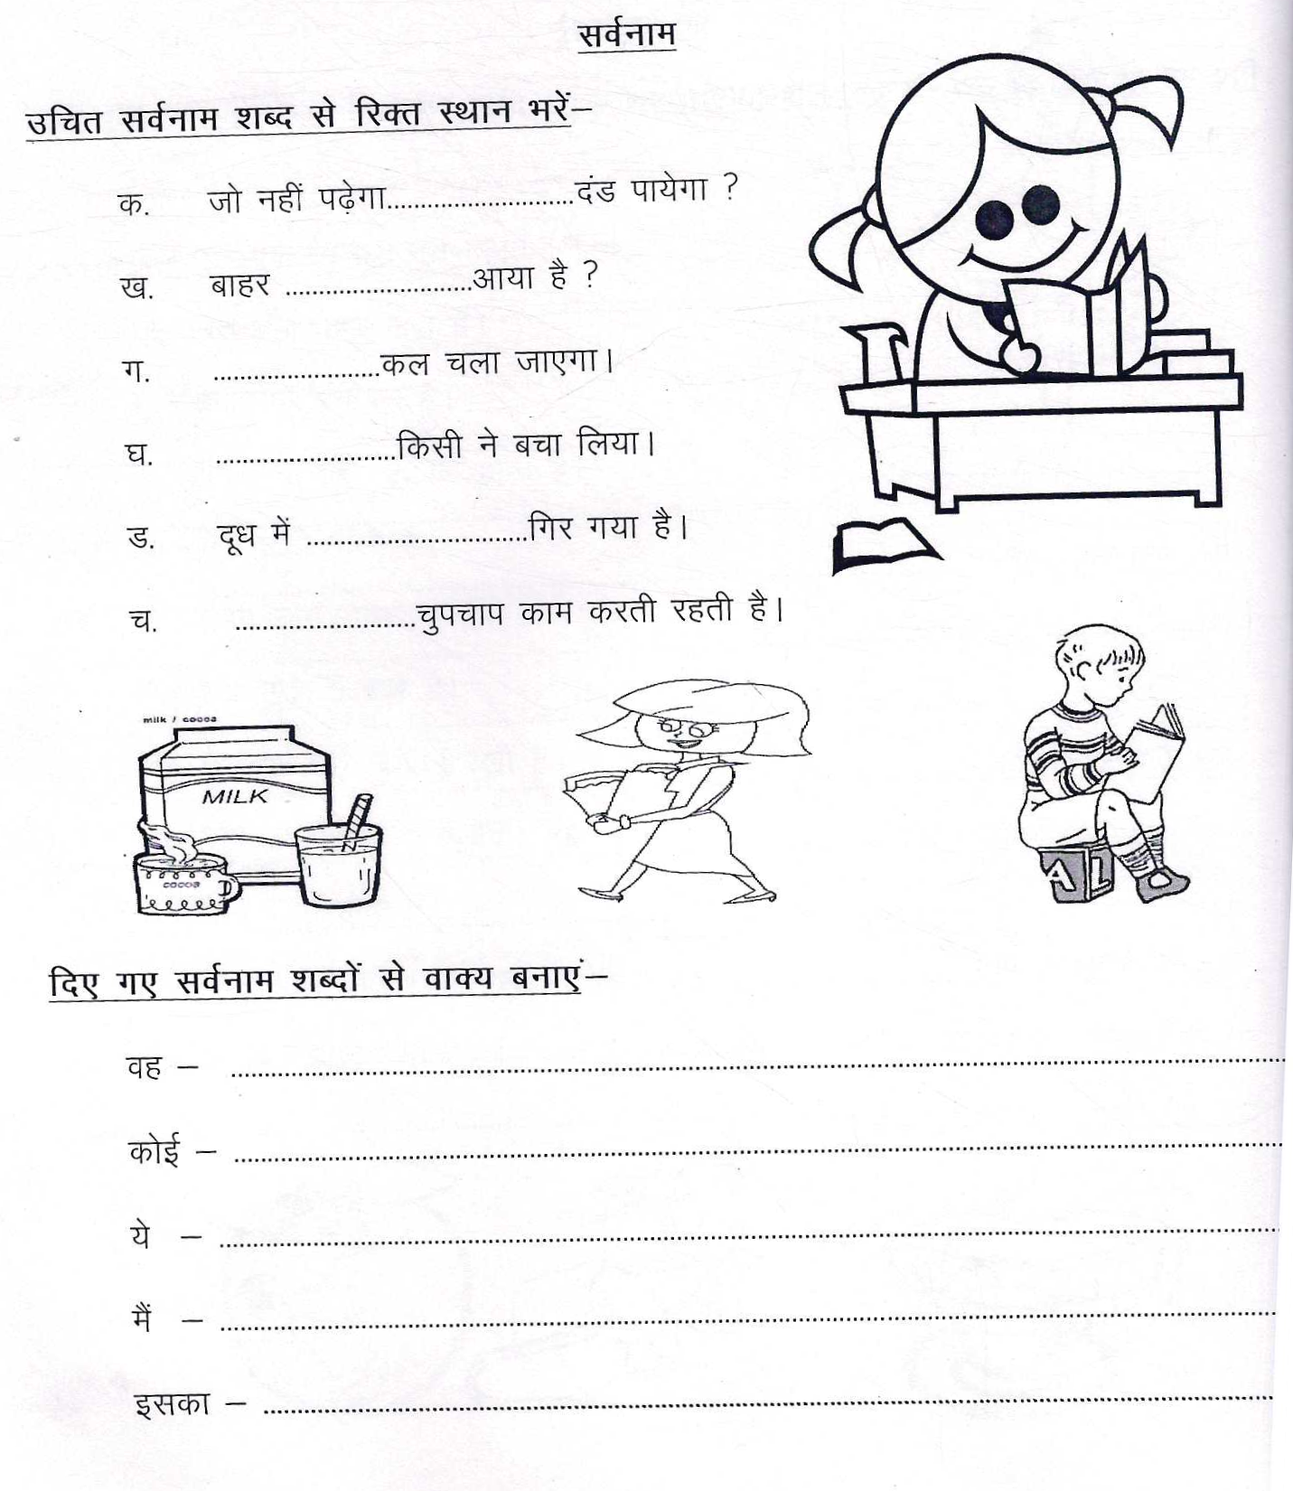
THE JAIN INTERNATIONAL SCHOOL
HOLIDAY HOME WORK
CLASS-4
Sheet No.2

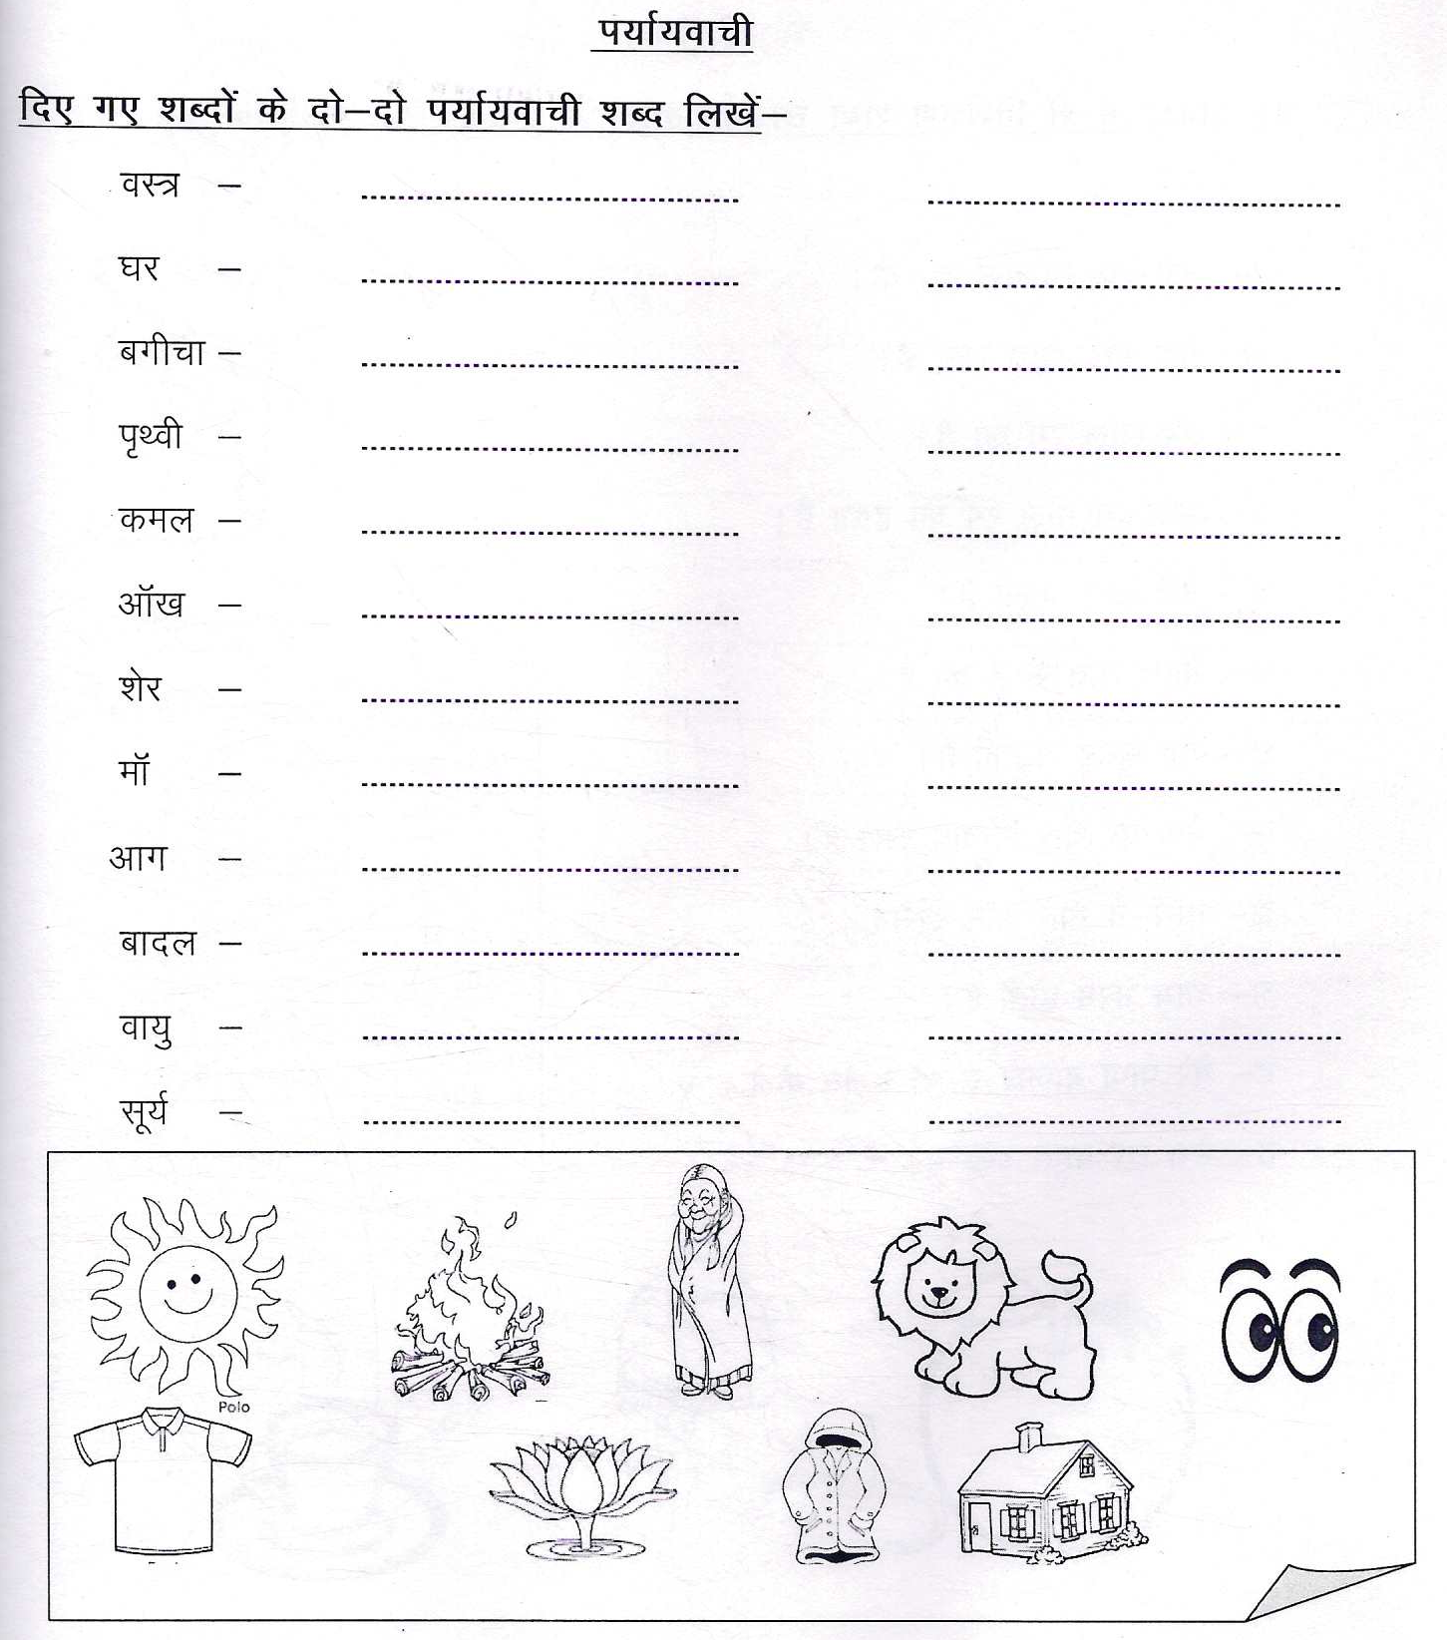

The Jain International School , Kanpur
Subject: Mathematics
Holiday Homework Worksheet 1
Class – IV
Name:- ___________________ Date: _______________
___________________________________________________________________________________
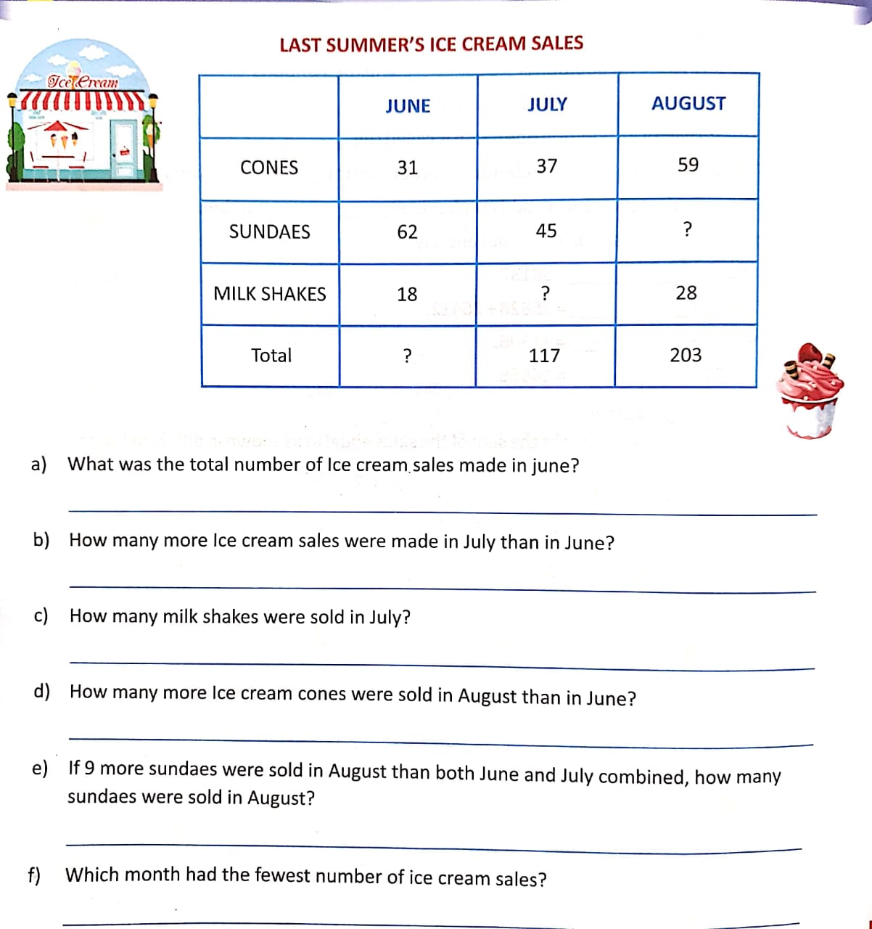

The Jain International School , Kanpur
Subject: Mathematics
Holiday Homework Worksheet 2
Class – IV
Name:- ___________________ Date: _______________
___________________________________________________________________________________

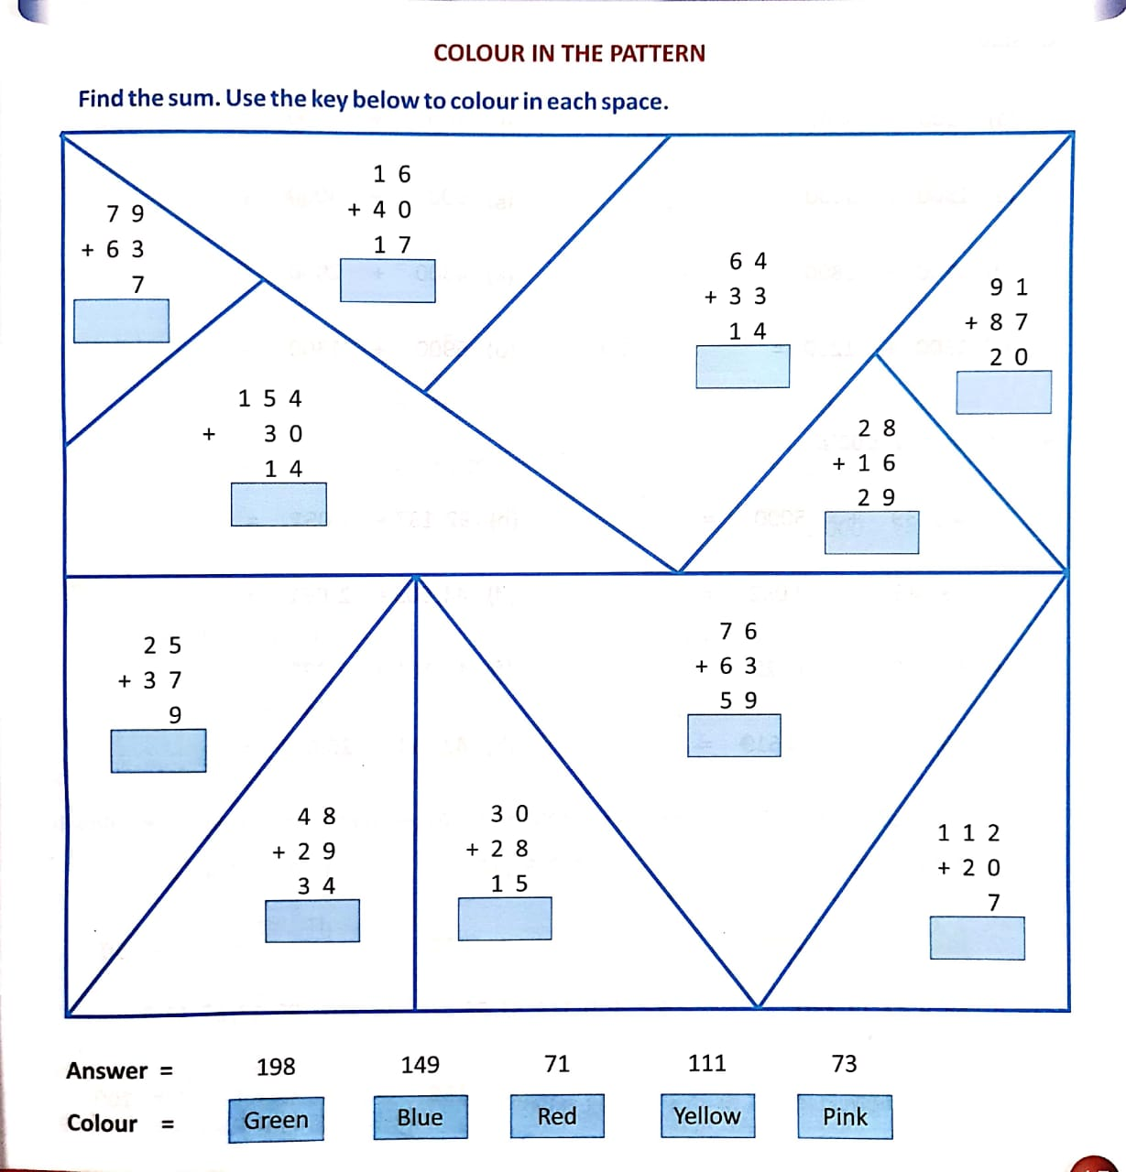

The Jain International School, Kanpur
Subject: Science
Holiday Homework Worksheet 1
Class – IV
Name:- ___________________ Date: _______________

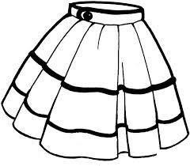
CLOTHES WE WEAR
Fill in the blanks with the given words:-
(warm, protect, cotton, raincoats, gumboots)
a). Clothes us from heat, cold and rain.
- We wear clothes in summer.
- Woollen clothes keep us .
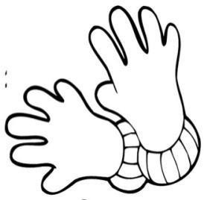
- We use and when it rains.

Write True or False:-
- Cotton clothes keep us cool. ( )
- We wear woollen clothes during rainy season. ( )
- We wear different clothes at different times of the year. ( )
- Linen fibres are obtained from animals. ( )
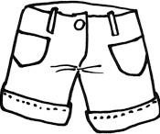
- Polyester is a natural fibre. ( )

Unscramble these letters to form words related to clothes:-
- L I S K -
- R Y D C E L A N -
- N L O Y N -
- T H E S I C Y N T -
- U T J E -

The Jain International School, Kanpur
Subject: Science
Holiday Homework Worksheet 2
Class – IV
Name:- ___________________ Date: _______________
______________________________________________________________________________
PLANTS
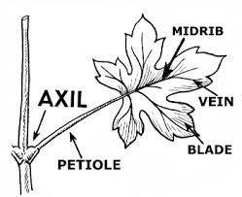
Tick the correct answer:-

- The process of making food in plants is called
a) interdependence b) photosynthesis
c) transportation d) digestion
- The food made in leaves is carried to all other parts of a plant by
a) stem b) bud
c) root hair d) flowers
- The green pigment in the leaves of a plant is
a) glucose b) starch
c) chlorophyll d) stoma

Write True or False:-
- Pitcher plant makes up its mineral deficiency by eating insects.
- Mushroom belongs to the insectivorous group of plants.
- In cactus, the green and fleshy part is modified into spines.
- Animals get carbon dioxide from plants to breathe.

Give two examples of each:-
- Saprophytic plants - ,

- Underwater plants - ,

The Jain International School , Kanpur
Subject: Social Studies
Holiday Homework Worksheet 1
Class – IV
Name:- ___________________ Date: _______________
______________________________________________________________________________

READING MAPS
Intermediate directions are halfway between the four cardinal directions. Write the names of the intermediate directions correctly on the lines:-

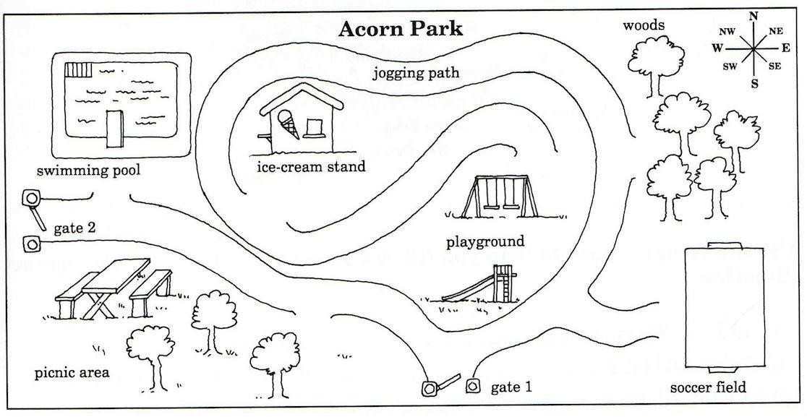
Use the names of the cardinal and intermediate directions to complete these sentences about the map of Acorn Park-
- The swimming pool is of the playground.
- The ice-cream stand is of the picnic area.
- The soccer field is of the swimming pool.
- The playground is of the picnic area.
- The woods are of the playground.
- Gate 2 is on the side of Acorn Park.
- The swimming pool is of the picnic area.
- Gate 1 is in the side of Acorn Park.
- The woods are of Gate 1.

The Jain International School , Kanpur
Subject: Social Studies
Holiday Homework Worksheet 2
Class – IV
Name:- ___________________ Date: _______________
_____________________________________________________________________________________

THE NORTHERN MOUNTAINS
Three Himalayan Ranges
Complete the Flow Chart:-
Name the following:-
1. Two ranges which lie in the Greater Himalayas are- ,
2. Other name of Lower Himalayas is-

3. 3 hill stations of Himachal region- , ,

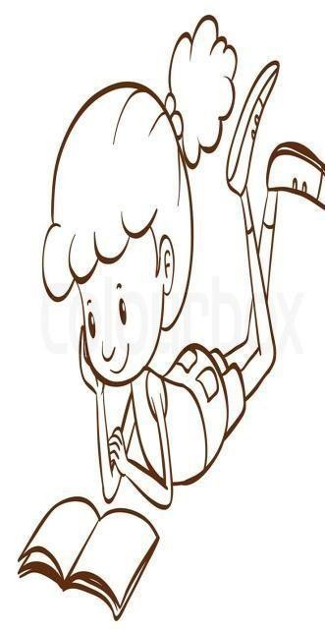
4. Houseboats found in Kashmir known as-

5. Pot with a burning coal-

6. Traditional tea of Kashmir is known as -

7. Traditional scarves of women-

8. Two north eastern states- ,

9. Two fruits grown in Sikkim- ,
__
_

10. Two crops grown in Mountains- , __________________

